Dollar Stock Rules
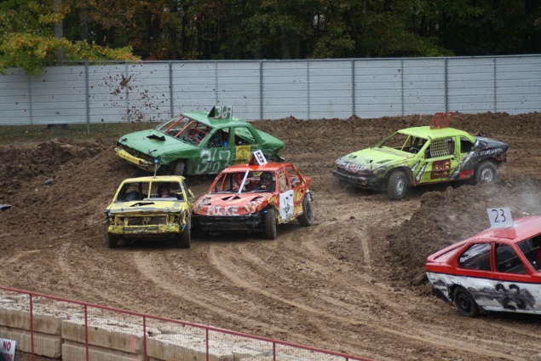
The Dollar Stock class is intended to be an entry-level and affordable class for all drivers where the cars are cheap to buy, the focus is fun, and maintenance is minimal. The cars will race around a small course with corners designated by tires in the infield to keep speeds at a safe level. The track size, layout, and race direction are subject to change on a weekly basis to prevent anyone from gaining an edge. The rules are designed with intent of lining up the cars to the compact demolition derby rules at the end of each season with minimal changes necessary should they choose to run in the derby.

General Rules:
1. Cars/minivans must be unibody, no full-frame vehicles or trucks/suvs
2. Cars and minivans may be front-wheel drive, rear-wheel drive, or all-wheel drive
3. All engines and transmissions must be stock, no aftermarket components
Wheels and Tires:
1. Must be DOT approved
2. No ATV or ‘chevron’ style agricultural mud tires (i.e. tractor tires)
3. Wheels must be stock, no bead-locks (steel rims are highly recommended)
4. Winter tires are allowed but must be de-studded
Suspension:
1. Stock, no alterations allowed
Body:
1. All glass must be completely removed (windows, headlights, taillights). Windshield area must have a wire mesh screen to protect the driver from rocks and debris.
2. Removing plastic bumper covers, trim pieces, and interior panels are highly recommended
Interior:
1. Removal of all plastic door panels, carpeting, and passenger seating is highly recommended
2. Demolition derby style door and driver seat bars are highly recommended
3. Minimum requirement is stock seat belt, 4 or e5 point harnesses are allowed

